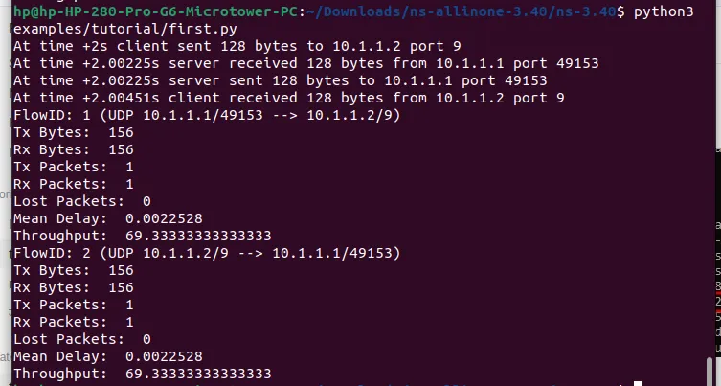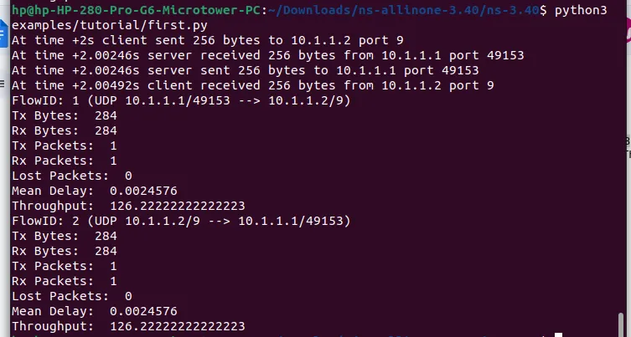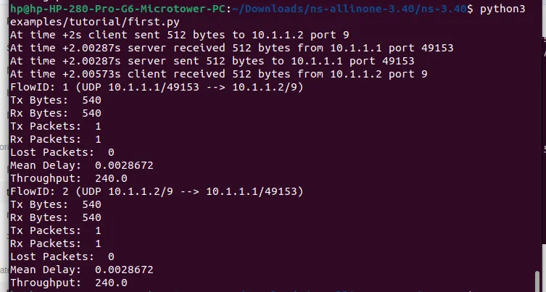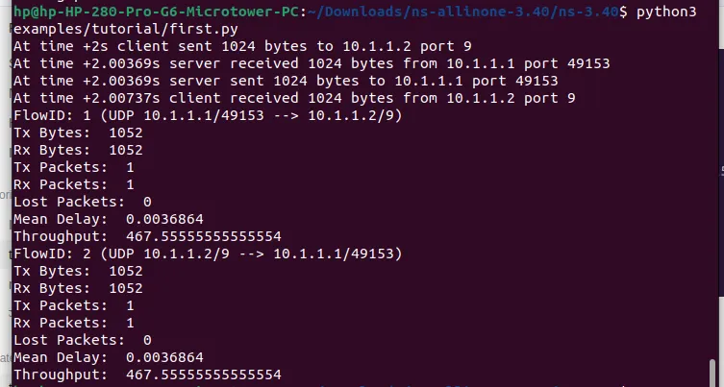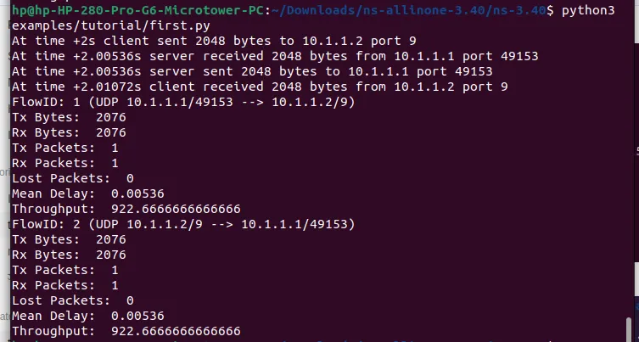

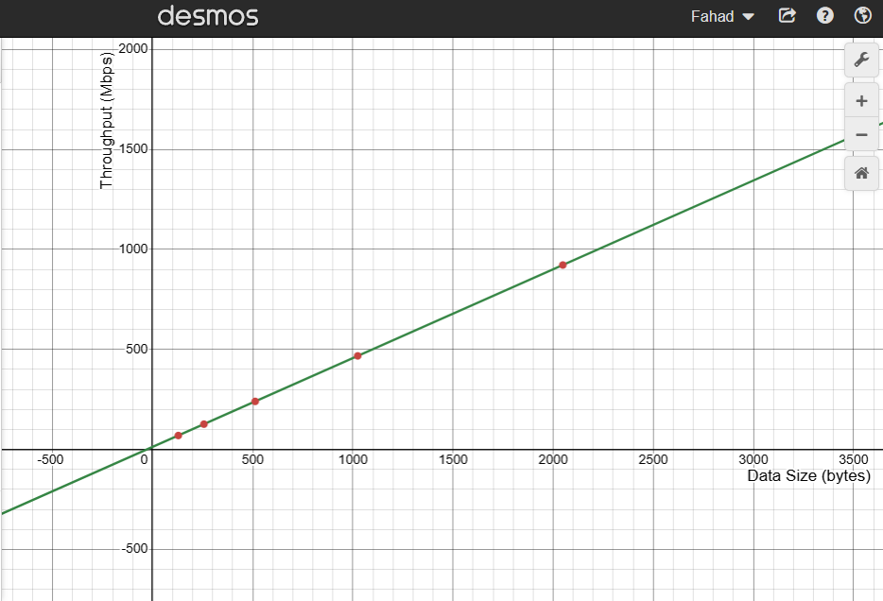

The graph plots throughput (in Mbps) on the y-axis against data size (in bytes) on the x-axis. The red data points represent measured values from network simulation results, while the green line suggests a linear trend.

The graph shows a directly proportional relationship between data size and throughput—indicating that as the data size increases, throughput also increases consistently. This suggests that larger data sizes lead to better network utilization, reducing the relative impact of protocol overhead. The near-linear pattern implies that the network is operating efficiently without significant congestion or bandwidth limitations within this range.